CB South Cross Country

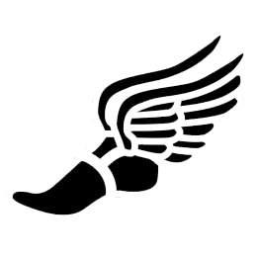



*2019 SCHEDULE*

**Day Date Event Time**

Wednesday 8/7/19 **PAPERWORK DEADLINE**

**-FAMILY ID & PHYSICAL SUBMITTED**

**TO ATHLETIC OFFICE (CAN UPLOAD PHYSICAL)**

Monday 8/12/19 **Official practice starts**  8:00 a.m.-

M-F (@ Peace Valley) 9:30 a.m.

S (optional) @ Green Lane

Wednesday 9/11/19 **Meet @ East with Pennridge** 3:30 p.m.

Saturday 9/14/19 **Centaur Invitational @DeSales U**  9:00 a.m.

Wednesday 9/18/19 **Meet @ Home vs Q-town/Souderton**  3:30 p.m.

Saturday 9/21/19 **CR Invite @ Tyler State Park** 9:00 a.m.

Wednesday 9/25/19 **Meet @ CBW (Peace Valley Park)** 3:30 p.m.

Wednesday 10/2/19 **Meet @ North Penn**  3:30 p.m.

Friday 10/18/19 **SOL Championships @ Lehigh U.** 9:00 a.m.

Friday 10/25/19 **District I Championships @ Lehigh U.** 9:00 a.m.

Fri-Sat. 11/01-11/02 **State Championships @ Hershey** 9:00 a.m.